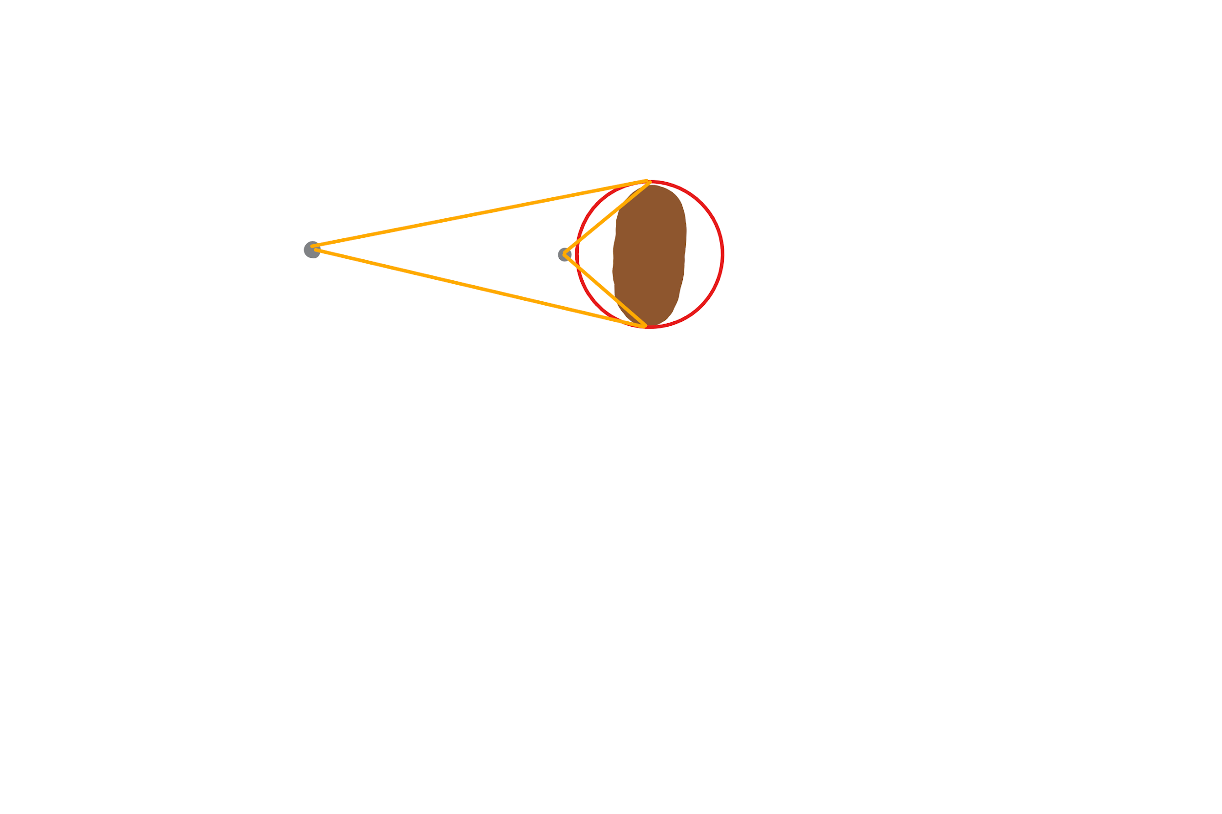

Due to the distance of the boat from the projectiles perspective the angle that means that the projectile will hit changes drastically. This is why the function being described is used. First of all it finds out the radius to which it would hit. It then compares this with the actual radius of the boat and if smaller then is classed as a projectile to dodge.